3 Detailed Design
3.2 Personal Resource Management Module
3.2.1 Module Specification
This module is designed for the customer to view, download and change the resources online. Divided by privilege, customer with different account could apply different operation to specific resource which is available to their account. In addition, any customer could view and deal with the resources uploaded by him in a special page. Which means that this module could also be used as a personal cloud.

3.2.2 Function
The IPO graph:
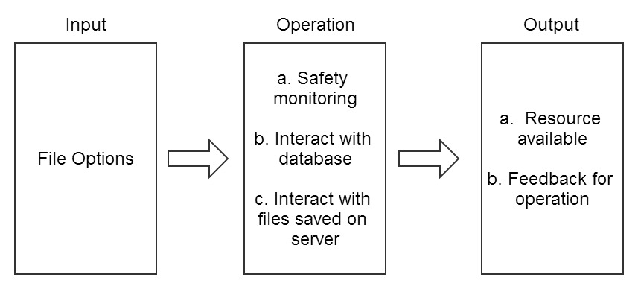
IPO graph for module 2
3.2.3 Performance
View resources online and click the download link to download.

3.2.4 Input item
Name | Signal | Type and format | Input format
Upload date of resource | Resource_Date | Date | Textbox
The uploader’s name | Resource_Uploader | Varchar | Textbox
The illustration of resource | Resource_Illustration | Varchar | Textbox
The level of resource | Resource_Level | Varchar | Textbox
List of input items for module 2

3.2.5 Output item
Name | Signal | Type and format | Input format
Course Name | Course_Name | Varchar | Textbox
The illustration of course | Course_Illustration | Varchar | Textbox
Resource | Resource | File | Download link
The name of resource | Resource_Name | Varchar | Textbox
Upload date of resource | Resource_Date | Date | Textbox
The uploader’s name | Resource_Uploader | Varchar | Textbox
The illustration of resource | Resource_Illustration | Varchar | Textbox
The level of resource | Resource_Level | Varchar | Textbox
List of output items for module 2

3.2.6 Algorithm
<?php
if(CheckStringSafety(form.Resource_Name)
&&CheckStringSafety(form.Resource_Date)
&&CheckStringSafety(form.Resource_Uploader)
&&CheckStringSafety(form.Resource_Illustration)
&&CheckStringSafety(form.Resource_Level)){
//Safety monitoring
ConnectionDB Db;
Db.open();
//Connect to the database
if(Session("login"==True))&&(form.Resource_Name!="")
//Login authentication
{
//If already login

if(form.Resource_Date!=""){
$query = "update file set Resource_Date=".$Resource_Date." where (select * form file where Resource_Name=".$Resource_Name")";
$result = $db->query($query);
}

if(form.Resource_Uploader!=""){
$query = "update file set Resource_Uploader=".$Resource_Uploader." where (select * form file where Resource_Name=".$Resource_Name")";
$result = $db->query($query);
}

if(form.Resource_Illustration!=""){
$query = "update file set Resource_Commit=".$Resource_Illustration." where (select * form file where Resource_Name=".$Resource_Name")";
$result = $db->query($query);
}

if(form.Resource_Level!=""){
$query = "update file set Resource_Level=".$Resource_Level." where (select * form file where Resource_Name=".$Resource_Name")";
$result = $db->query($query);
}
//Update data to database
}
else
{
//not login correctly
$data['result']="Please login";
header("location: ./welcome.html");
}
Db.close();
//close database connection
}
echo json_encode($data);
//Return the result
?>
3.2.7 Process and logic
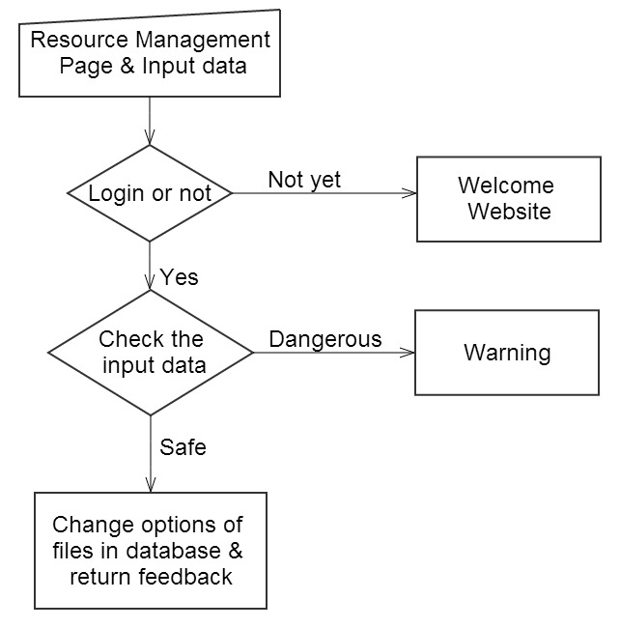
3.2.8 Interface
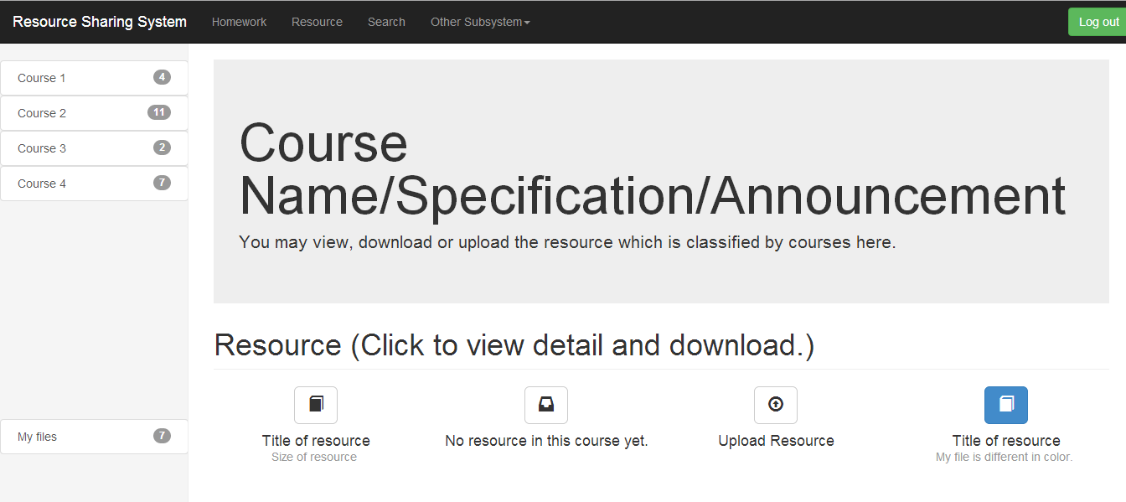
The whole interface of module 2


The button to trigger the change of options of specific resource.
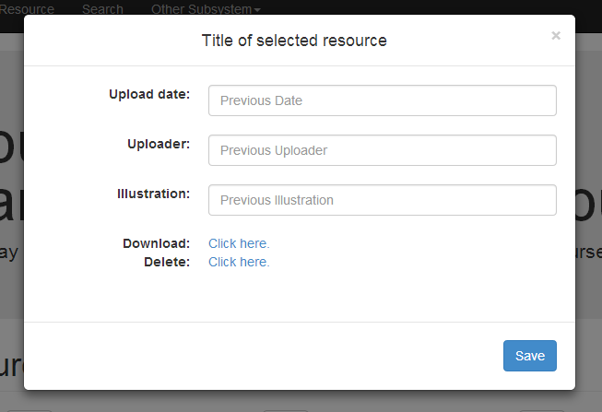
The interface to change the options of specific resource.
3.2.9 Test Design
Input data | Expected Result
Normal options of file. | None.(The options of file successfully changed)
Text including SQL sentence and illegal symbols. | Warning message.
The user didn't log in. | Jump to welcome website.

3.3 Personal Resource Management Module
3.3.1 Module Specification
This module is designed for the customer to upload a file as a resource to the server. It shares the same website with module 2.

3.3.2 Function
The IPO graph:
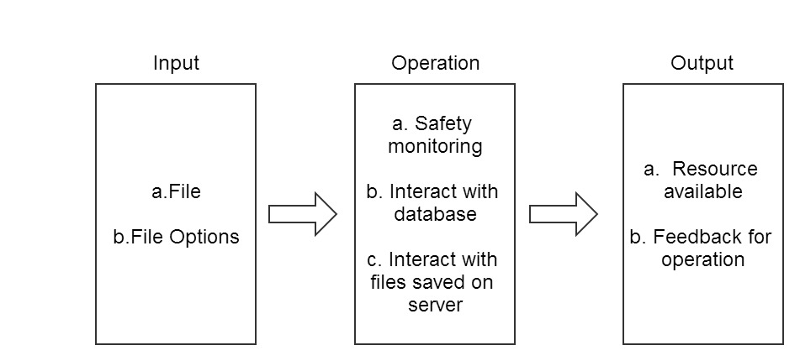
IPO graph for module 3
3.3.3 Performance
Select file and input file options to upload a file as the resource to the cloud.

3.3.4 Input item
Name | Signal | Type and format | Input format
Resource | Resource | File | Upload button
The illustration of resource | Resource_Illustration | Varchar | Textbox
List of input items for module 3

3.3.5 Output item
None output items are involved in this module.

3.3.6 Algorithm
<?php
if ((($_FILES["file"]["type"] == "image/gif")
|| ($_FILES["file"]["type"] == "image/jpeg")
|| ($_FILES["file"]["type"] == "image/pjpeg"))
&& ($_FILES["file"]["size"] < 20000))
&& CheckStringSafety(form.Resource_Illustration)
//Safety monitoring
{
if (Session("login"==True))
//Login authentication
{
//If alreadly login
ConnectionDB Db;
Db.open();
//Connect to the database
$query = "insert into file values (".$_FILES["file"]["tmp_name"].",".$_FILES["file"]["type"].",".$_FILES["file"]["size"].",".form.Resource_Illustration.")";
$result = $db->query($query);
Db.close();
//close database connection
if ($_FILES["file"]["error"] > 0)
{
$data['result']="Return Code: " . $_FILES["file"]["error"] . "<br />";
}
else
{

if (file_exists("upload/" . $_FILES["file"]["name"]))
{
$data['result']=$_FILES["file"]["name"] . " already exists. ";
}
else
{
move_uploaded_file($_FILES["file"]["tmp_name"],
"upload/" . $_FILES["file"]["name"]);
}
}
//Upload file
}
}
else
{
$data['result']="Invalid file or input";
}
echo json_encode($data);
//Return the result
?>
3.3.7 Process and logic
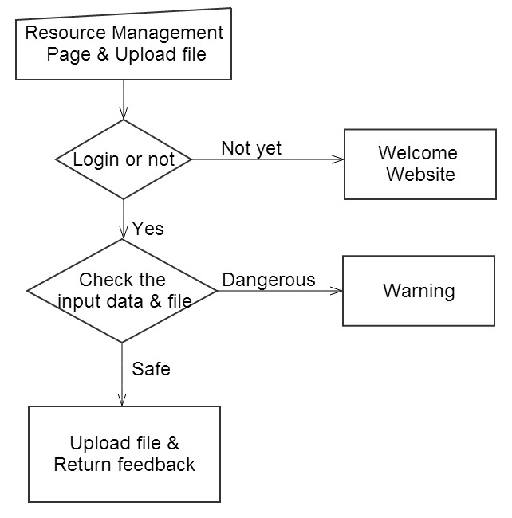
3.3.8 Interface

The button to trigger upload operation
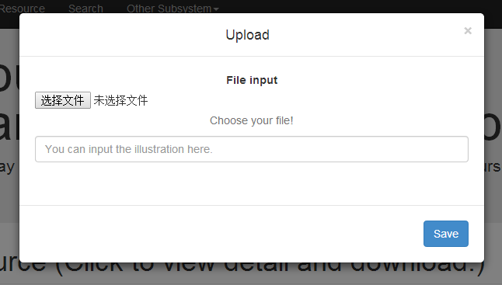
The interface of upload operation
3.2.9 Test Design
Input data | Expected Result
Normal files and illustration. | A message of successfully uploaded.
Text including SQL sentence and illegal symbols. | Warning message.
The user didn't log in. | Jump to welcome website.

3.4 Search Module
3.4.1 Module Specification
This module is designed for the customer to search a file from all the homeworks and resources. This module provides two way to search and several optional search items to help the customer to perform a search with high-accuracy.

3.4.2 Function
The IPO graph:
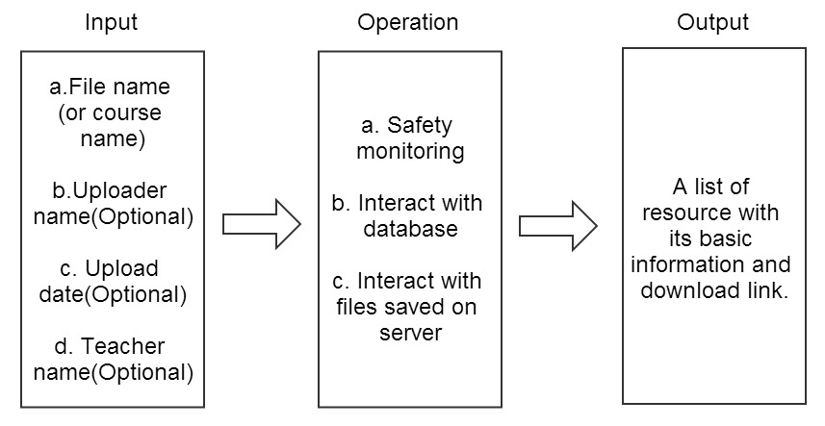
IPO graph for module 4
3.4.3 Performance
Input keywords to search for resources and homeworks in the server and return the related files with its download link.

3.4.4 Input item
Name | Signal | Type and format | Input format
The name of resource | Resource_Name | Varchar | Textbox
The name of homework | Homework_Name | Varchar | Textbox
The name of course | Course_Name | Varchar | Textbox
The name of uploader | Uploader_Name | Varchar | Textbox
The upload date | Upload_Date | Varchar | Textbox
The name of teacher | Teacher_Name | Varchar | Textbox
List of input items for module 4

3.4.5 Output item

Name | Signal | Type and format | Input format
Resource | Resource | File | Download Link
Homework | Homework | File | Download Link
The name of resource | Resource_Name | Varchar | Textbox
The name of homework | Homework_Name | Varchar | Textbox
Course Name | Course_Name | Varchar | Textbox
The illustration of course | Course_Illustration | Varchar | Textbox
List of Output items for module 4

3.4.6 Algorithm
<?php
if(CheckStringSafety(form.File_Name)
&&(form.Course_Name)
&&(form.Uploader_Name)
&&(form.Upload_Date)
&&(form.Teacher_Name)){
//Safety monitoring
ConnectionDB Db;
Db.open();
$File_Name=form.File_Name;
$Course_Name=form.Course_Name;
$Uploader_Name=form.Uploader_Name;
$Upload_Date=form.Upload_Date;
$Teacher_Name=form.Teacher_Name;
//Connect to the database
if(Session("login"==True))&&(form.Resource_Name!="")
//Login authentication
{
//If already login
if(form.File_Name!=""){
$query = "select * from file where (file_name like '%".$File_Name."%') and (Course_Name like '%".$Course_Name."%') and (Uploader_Name like '%".$Uploader_Name."%') and (Upload_Date like '%".$Upload_Date."%')";
$result = $db->query($query);
}

if(form.Course_Name!=""){
$query = "select * from course where Course_Name like '%".$Course_Name."%' and (Teacher_Name like '%".$Teacher_Name."%')";
$result = $db->query($query);
}
//Search in the Database
$num_results = $result->num_rows;

for ($i=0; $i <$num_results; $i++) {
$row = $result->fetch_assoc();
$data['array_file_name']=$row['file_name'];
$data['array_course_name']=$row['course_name'];
$data['array_course_illustration']=$row['course_illustration'];
}
}
else
{
//not login correctly
$data['result']="Please login";
header("location: ./welcome.html");
}
Db.close();
//close database connection
}
echo json_encode($data);
//Return the result
?>
3.4.7 Process and logic
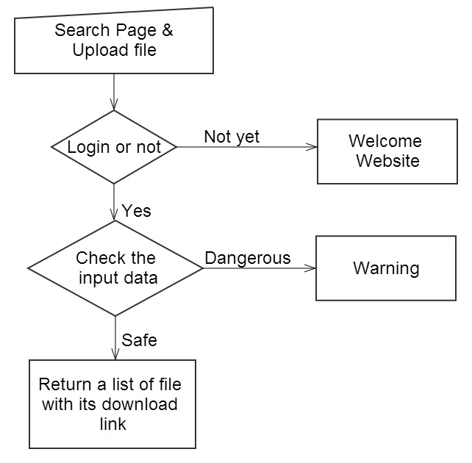
3.4.8 Interface
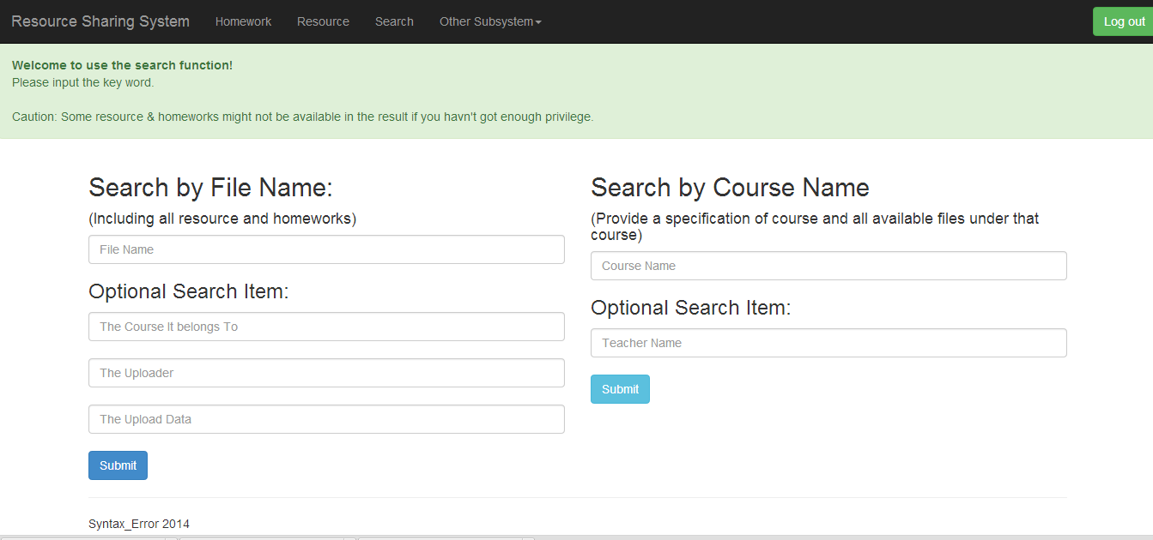
The interface of search operation
3.2.9 Test Design
Input data | Expected Result
Normal input of keyword. | Jump to the result of search.
Text including SQL sentence and illegal symbols. | Warning message.
The user didn't log in. | Jump to welcome website.

